**Topic review — Topic 3: Composite functions, transformations and inverses**

**Short answer**

1. Consider the equations ,  and , .

**a** Prove that  is defined.

**b** Find the rule for  and state the domain and range.

**c** Prove that  is not defined.

**d** Restrict the domain of  to obtain a function  such that  exists.

**e** Find and state the domain.

1. A function has the rule , .

**c** Sketch the graph of , . State the domain and range, and give the equations of any asymptotes.

**d** Find the rule for the inverse, and state its domain and range.

**e** Specify whether the inverse is a function or a relation. Give reasons for your answer.

**f** Sketch the graph of the inverse on the same set of axes as the original function. Include the points of intersection on your graph

1. Indicate whether each of the following functions has an inverse function. In each case, give a reason for your decision. If the inverse is a function, write the rule for the inverse function in function notation.

**a** , 

**b** , 

**c** , 

**d** , 

**e** , 

**6a** Consider the functional equation defined by . Which of the

following functions satisfies this equation?

**i** 

**ii** 

**iii** 

**b** Consider the functional equation defined by .

**i** Show that the function  obeys this rule.

**ii** Show that the function  obeys this rule.

**c** For , show that  can be written in the form  and find the value of .

**Multiple choice**

1. If  and , then  is equal to:

**A** 

**B** 

**C** 

**D** 

**E** 

1. For the functions below, which of the following compositions is not defined?







**A** 

**B** 

**C** 

**D** 

**E** 

1. If , then  would exist if:

**A** , 

**B** , 

**C** , 

**D** , 

**E** , 

1. If , which of the following functional equations is true?

**A** 

**B** 

**C** 

**D** 

**E** 

1. The graph of the function  is transformed so that its new rule is . The transformations that have been applied to  are:

**A** dilation by a factor of  parallel to the -axis, dilation by a factor of 2 parallel to the -axis, a translation of 1 unit in the negative -direction and a translation of 4 units up

**B** dilation by a factor of  parallel to the -axis, dilation by a factor of 2 parallel to the -axis, a translation of 1 unit in the positive -direction and a translation of 4 units up

**C** dilation by a factor of  parallel to the -axis, dilation by a factor of  parallel to the -axis, a translation of 1 unit in the negative -direction and a translation of 4 units up

**D** dilation by a factor of  parallel to the -axis, dilation by a factor of  parallel to the -axis, a translation of 1 unit in the positive -direction and a translation of 4 units up

**E** dilation by a factor of 2 parallel to the -axis, dilation by a factor of  parallel to the -axis, a translation of 1 unit in the negative -direction and a translation of 4 units up

1. The following matrix equation is applied to .



This causes  to be:

**A** reflected in the -axis and dilated by a factor of 2 from the -axis

**B** reflected in the -axis and dilated by a factor of 2 from the -axis

**C** reflected in the -axis and dilated by a factor of 2 from the -axis

**D** reflected in the -axis and dilated by a factor of  from the -axis

**E** reflected in both axes and dilated by a factor of 2 from the -axis

1. The rule for the inverse of the graph shown would be:

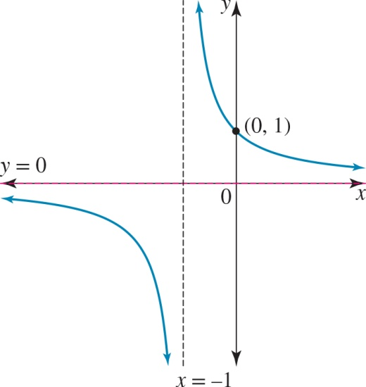

**A** 

**B** 

**C** 

**D** 

**E** 

1. For the function  to have an inverse, its maximal domain:

**A** must be restricted to 

**B** must be restricted to 

**C** must be restricted to 

**D** is 

**E** must be restricted to 

1. The inverse of the function defined by ,  would be:

**A** , 

**B** , 

**C** , 

**D** , 

**E** , 

**Extended response**

1. Consider the function defined by .

**a** Sketch this graph, giving the domain and range of the function.

**b** Find the rule for the inverse.

**c** Sketch this inverse on the same set of axes that you used for .

**d** Restrict the domain of  to the form of  so that the inverse is also a function.

**e** State the rules for the restricted  and  using function notation.

**f** Sketch the graphs of  and  on one set of axes.

**g** Show that .

1. Consider the function defined by the rule ,  where  is the maximal domain for .

**a** Find .

**b** Describe the transformations that would have been applied to  in order to achieve .

**c** Write a matrix equation that defines these transformations and solve the matrix equation to confirm this is correct.

**d** Define the rule for the inverse function  and give its domain and range.

**e** Sketch the graphs of  and  on the same set of axes.

1. **a** If ,  and , , where  is a positive constant, find the value(s) of  such that both  and  are defined.

**b** The transformation  is defined by , where , ,  and  are non-zero real numbers. If the image of the curve  is , find the values of , ,  and .

1. **a** If , show that it obeys the functional equation defined by .

**b** If , show that it obeys the functional equation defined by **.**

**Topic review — answers**

**Short answer**

**1 a** For to exist, the range of the inner function, ,must be a subset of or equal to   
 the domain of the outer function, .



Therefore,  is defined.

**b** 

Domain = , range = 

**c** For to exist the range of the inner function,  must be a subset of or equal to   
 the domain of the outer function, .



Therefore,  is not defined.

**d** , 

**e **

Domain = 

**2**

**c** ; domain =  and range = 

Asymptotes:  and 

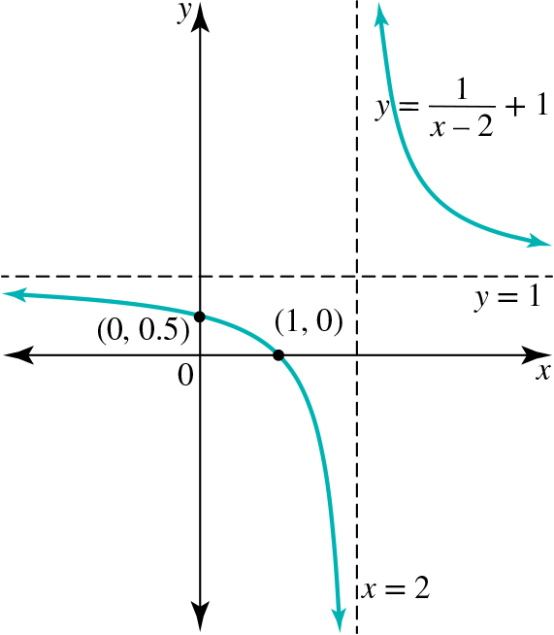

**d** , domain =  and range = 

**e** The inverse is a one-to-one function.

**f**

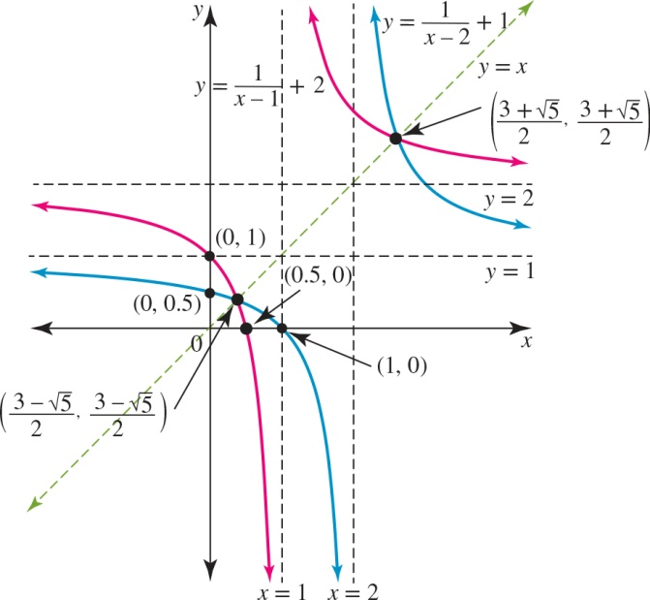

**3 a** One-to-one inverse function: , 

**b** Not a function, as it is a one-to-many mapping.

**c** Not a function, as it is a one-to-many mapping.

**d** Not a function, as it is a one-to-many mapping.

**e** One-to-one inverse function: , 

**6 a** **i** No **ii** Yes

**iii** Yes

**b i **





Because  is positive in the 2nd quadrant,   
.

Therefore,



**ii **





Because  is negative in the 2nd quadrant,   
.

Therefore,



**c** 





**Multiple choice**

**1** A **2** D **3** A **4** C

**6** D **7** B **8** C **9** B **10** D

**Extended response**

**1 a**, **c** The domain of  is  and the range of  is .

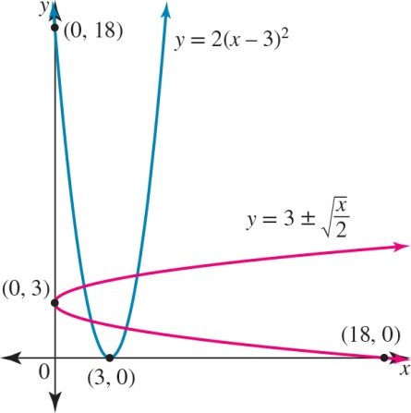

**b** ; domain = and range = 

**d** The domain should be .

**e** , 

, 

**f**

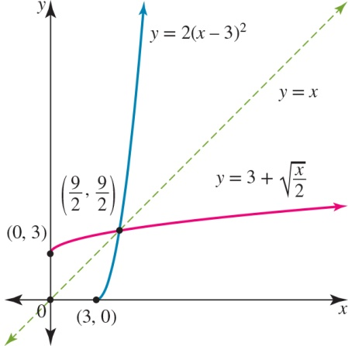

**g** 



**2 a** 

**b** One possible answer is:

Dilated by a factor of parallel to the -axis or from the -axis, translated 2 units to the right or in the positive -direction and translated 1 unit down or in the negative -direction

**c** 

**d**  with range = 

**e**

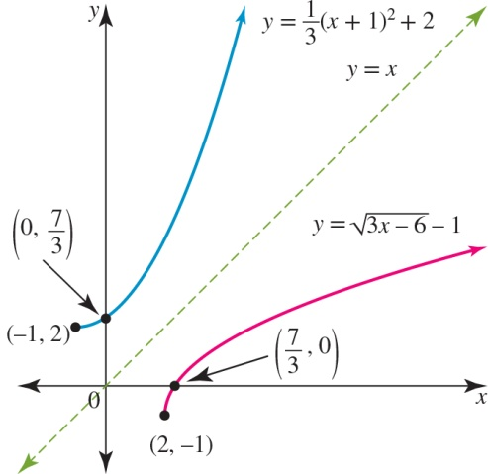

**3 a **

**b** , ,  and 

**4 a **





:



**b **





:

